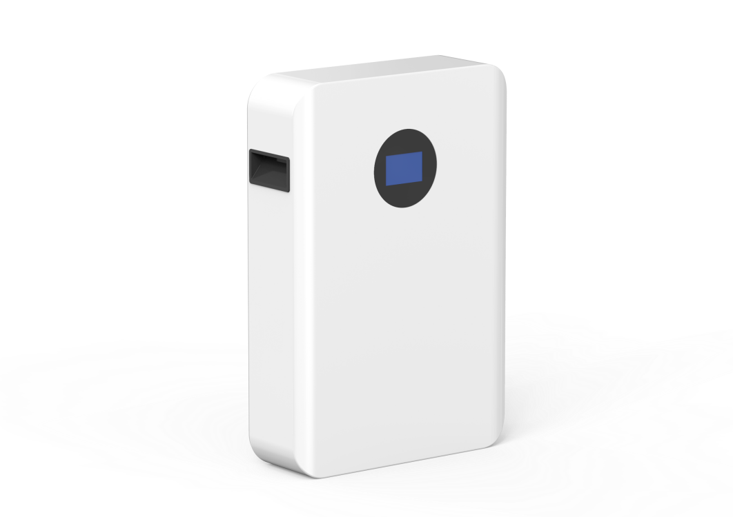

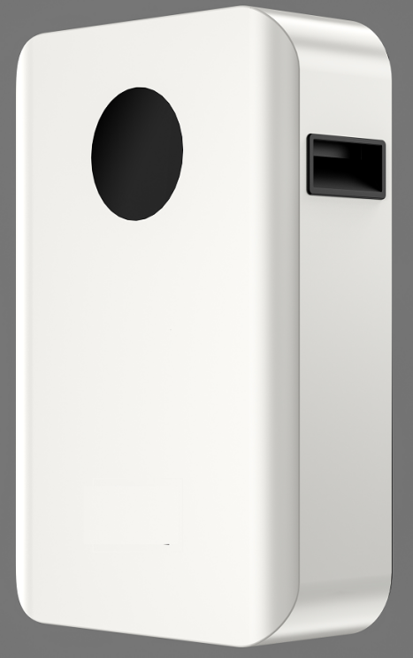

**Rechargeable** **Li-ion** **Battery**

**Operation** **Manual**

Information Version:

**ReV1.0**

This manual introduces from Our team. Please read this manual before you to install the battery and follow the instruction carefully during the installation process. Any confusion, please contact Our team immediately for advice and clarification.

1.  **Symbol in label, manual and product**.......................................................3

2.  **Safety Precautions**.....................................................................................4

2.1 Before Connecting.................................................................................5

2.2 In Using.................................................................................................5

3.  **Introduction**...............................................................................................6

3.1 Features..........................................................................................6

3.2 Specification....................................................................................7

3.3 Equipment interface instruction........................................................8

4. **Safe handling of lithium batteries guide**.................................................13

4.1 Danger label...................................................................................13

4.2 Safety gear....................................................................................13

5.  **Installation and operation**.......................................................................14

5.1 Installation location ........................................................................14

5.2 For External cable kits...................................................................15

5.3 Grounding......................................................................................15

6. **Trouble shooting**.....................................................................................16

7. **Emergency Situations**............................................................................18

8.  **Remarks**..................................................................................................19

**1.** **Symbol** **in** **label,** **manual** **and** **product**

|  |  |
| --- | --- |
| C:\Users\Administrator\Desktop\康总5款\TU1.pngTU1 | Caution! Warning! Reminding.  Safety related information.  Risk of battery system failure or life cycle reduces. |
| TU2 | Do not reverse connection the positive and negative. |
| TU3 | Do not place near open flame |
| TU4 | Do not place at the children and pet touchable area. |
| TU5 | Warning electric shock . |
| TU6 | Warning Fire.  Do not place near flammable material |
| TU7 | Read the product and operation manual before operating the battery system! |
| TU8 | Grounding. |
| TU9 | Recycle label. |
| TU10 | Label for Waste Electrical and Electronic Equipment (WEEE) Directive (2012/19/EU) |

**2.** **Safety** **Precautions**



**Reminding**

* It is important and necessary to read the user manual carefully before installing or using battery. Failure to do so or to follow any of the instructions or warnings in this document can result in electrical shock, serious injury, or death, or can damage battery, potentially rendering it inoperable
* If the battery is stored for long time, it is required to charge them every three months, and the SOC should be no less than 90%
* Battery needs to be recharged within 12 hours, after fully discharged
* Do not install the product in outdoor environment, or an environment out of the operation temperature or humidity range listed in manual.
* Do not expose cable outside
* Do not connect power terminal reversely.
* All the battery terminals must be disconnected for maintenance
* Do not use cleaning solvents to clean battery
* Do not expose battery to flammable or harsh chemicals or vapors
* Do not paint any part of battery, include any internal or external components
* Do not connect battery with PV solar wiring directly
* The warranty claims are excluded for direct or indirect damage due to items above.
* Any foreign object is prohibited to insert into any part of battery



**Warning**

**2.1** **Before** **Connecting**

1) After unpacking, please check product and packing list first, if product is damaged or lack of parts, please contact with the local retailer

2) Before installation, be sure to cut off the grid power and make sure the battery is in the turned-off mode

3) Wiring must be correct, do not mistake the positive and negative cables, and ensure no short circuit with the external device

4) It is prohibited to connect the battery and AC power directly

5) The embedded BMS in the battery is designed for 51.2VDC, please DO NOT connect battery in series

6) Battery must connect to ground and the resistance must be less than 0. 1Ω

7) Please ensured the electrical parameters of battery system are compatible to related equipment

8) Keep the battery away from water and fire.

**2.2** **In** **Using**

1) If the battery system needs to be moved or repaired, the power must be cut off and the battery is completely shutdown

2) It is prohibited to connect the battery with different type of battery.

3) It is prohibited to connect batteries with faulty or incompatible inverter

4) It is prohibited to disassemble the battery (QC tab removed or damaged);

5) Please do not open, repair or disassemble the battery except staffs from Our team or authorized by Our team. We do not undertake any consequences or related responsibility which because of violation of safety operation or violating of design, production and equipment safety standards.

**3.** **Introduction**

lithium iron phosphate battery is the new energy storage products developed and produced by Our team, it can be used to support reliable power for various types of equipment and systems.

has built-in BMS battery management system, which can manage and monitor cells information including voltage, current and temperature.

**3.1** **Features**

* NEW: Build-in soft-start function able to reduce current strike when inverter need to start from battery.
* NEW: Dual active protection on BMS level.
* NEW: Manually set the address when connecting multiple groups..
* NEW: Support communication via CAN or RS485
* NEW: Enable 95% depth of discharge, available for the inverter which completely follow Our team latest protocol to operate.
* The module is non-toxic, non-pollution and environmentally friendly
* Cathode material is made from LiFePO4 with safety performance and long cycle life
* Battery management system (BMS)has protection functions including over- discharge, over-charge, over-current and high/low temperature
* The system can automatically manage charge and discharge state and balance voltage of each cell
* Flexible configuration, multiple battery modules can be in parallel for expanding capacity and power
* Adopted self-cooling mode rapidly reduced system entire noise
* The module has less self-discharge, up to 3 months without charging it on shelf, no memory effect, excellent performance of shallow charge and discharge
* Small size and light weight, standard of 19-inch embedded designed module is comfortable for installation and maintenance

**3.2** **Specification**

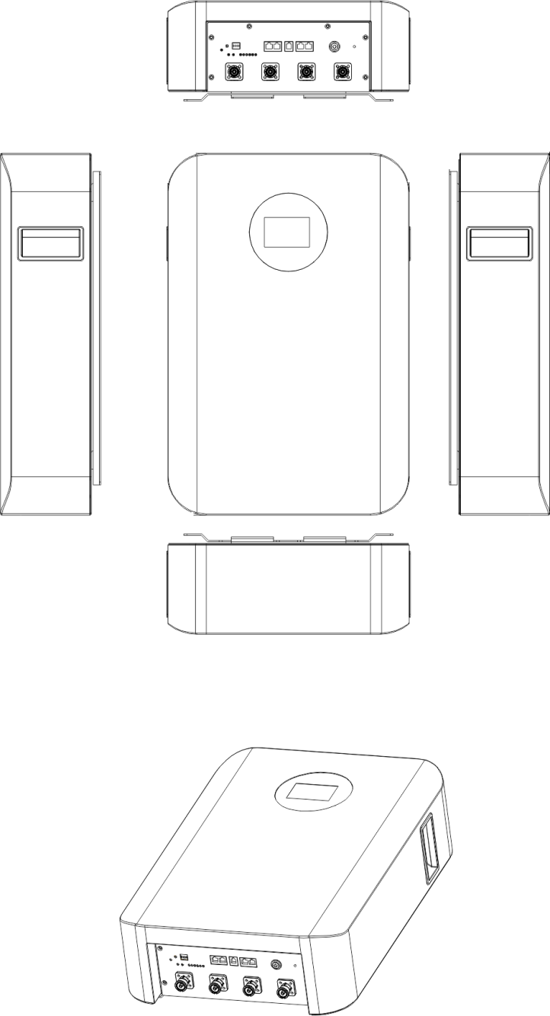

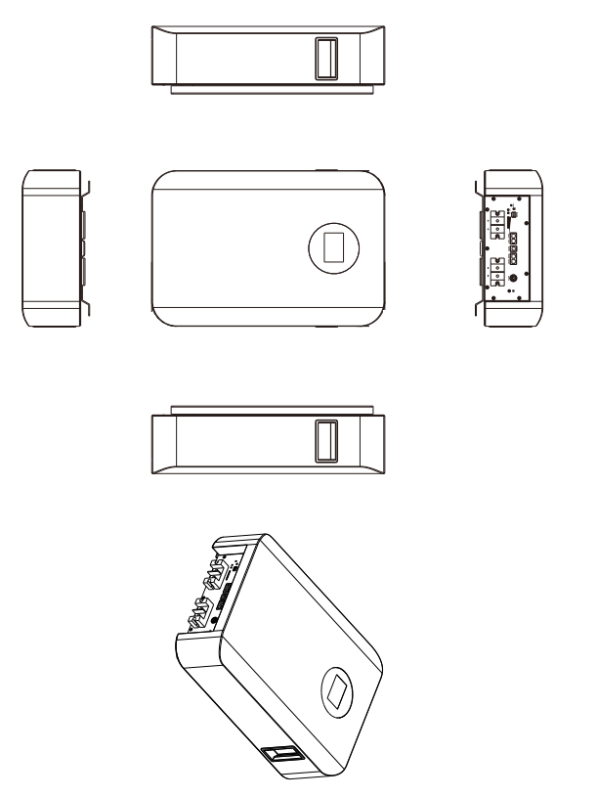

**3.3** **Equipment** **interface** **instruction**

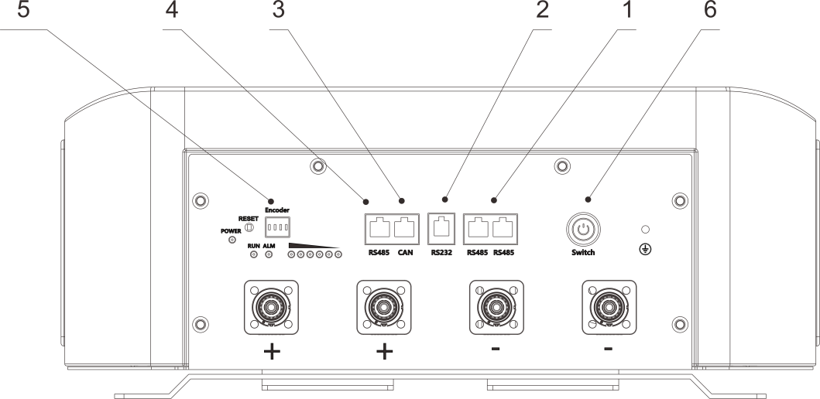

1. RS485 communication port, and the battery is used for parallel communication
2. RS232 communication port， is used for software upgrading and maintenance
3. CAN communication port， is used for communication with battery and inverter
4. RS485 communication port， is used for communication between battery and inverter
5. The communication address coding switch， is used to set the communication address when the batteries are connected in parallel. The address of the battery communicating with the inverter is "1"
6. Start button: when the button is pressed, the battery starts to work with voltage output; when the button is released, the battery shuts down without voltage output
7. RS485 communication port, and the battery is used for parallel communication
8. RS232 communication port， is used for software upgrading and maintenance
9. CAN communication port， is used for communication with battery and inverter
10. RS485 communication port， is used for communication between battery and inverter
11. The communication address coding switch， is used to set the communication address when the batteries are connected in parallel. The address of the battery communicating with the inverter is "1"
12. Start button: when the button is pressed, the battery starts to work with voltage output; when the button is released, the battery shuts down without voltage output

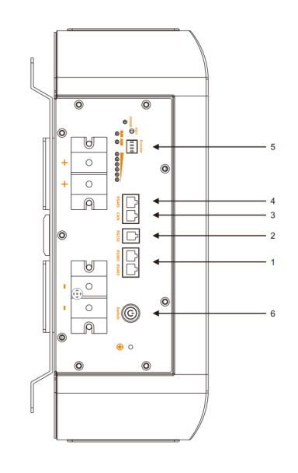

**Start button**

Press: Power on, battery working

break off: power off. For storage or shipping.

**RUN**

Green LED lighting to show the battery running status

**Alarm**

Red LED flashing to show the battery has alarm; lighting to show the battery is under protection.

**Reset**

This reset has the functions of manual wake up and start, manual shutdown and sleep, and reset. Users can flexibly use it according to the actual situation. The specific operation methods are as follows:

1.Manual wake up function: When BMS is in hibernation state, press the button for 3S and release it. BMS will be activated and the battery will return to normal working mode

2. Manual sleep: When the battery is in the normal working state, press the button for 3 seconds and release the button. The battery enters the low-power sleep state

3. Reset function: Press for more than 6s to reset the battery when the battery is in normal working state.

**ADD** **Switch**

If battery strings are connected in parallel and need to communicate in cascading mode, the hardware address of each battery must be configured. The hardware address can be set using the dip switch on the board.

When the batteries are in parallel, address 1 is the host and other addresses are slave. The battery at address 1 is connected to the inverter；If the address is 0, it is in single-battery mode

For details about the switch, see the following table.



|  |  |  |  |  |  |
| --- | --- | --- | --- | --- | --- |
| **switch position** | | | | **address** | **Battery Address Definition** |
| **1** | **2** | **3** | **4** |
| OFF | OFF | OFF | OFF | 0 | PACK0 |
| ON | OFF | OFF | OFF | 1 | PACK1 |
| OFF | ON | OFF | OFF | 2 | PACK2 |
| ON | ON | OFF | OFF | 3 | PACK3 |
| OFF | OFF | ON | OFF | 4 | PACK4 |
| ON | OFF | ON | OFF | 5 | PACK5 |
| OFF | ON | ON | OFF | 6 | PACK6 |
| ON | ON | ON | OFF | 7 | PACK7 |
| OFF | OFF | OFF | ON | 8 | PACK8 |
| ON | OFF | OFF | ON | 9 | PACK9 |
| OFF | ON | OFF | ON | 10 | PACK10 |
| ON | ON | OFF | ON | 11 | PACK11 |
| OFF | OFF | ON | ON | 12 | PACK12 |
| ON | OFF | ON | ON | 13 | PACK13 |
| OFF | ON | ON | ON | 14 | PACK14 |
| ON | ON | ON | ON | 15 | PACK15 |

**CAN**

CAN terminal :(RJ45 port) the CAN terminal outputs battery information. The default baud rate is 500K. When batteries are deployed in parallel, you need to set the address of each battery using a dip switch.

|  |  |
| --- | --- |
| Pin definitions of the CAN port | |
| Pin number | 1658366400747Function definition |
| Foot 1 | NC |
| Foot 2 | NC |
| Foot 3 | NC |
| Foot 4 | CAN-H |
| Foot 5 | CAN-L |
| Foot 6 | NC  **RJ45 Port** |
| Foot 7 | NC |
| Foot 8 | NC |

**RS485**

RS485 terminal :(RJ45 port) the RS485 terminal outputs battery information. The default baud rate is 9600bpS. When batteries are deployed in parallel, you need to set the address of each battery using a dip switch.

|  |  |
| --- | --- |
| Pin definitions of the RS485 port | |
| Pin number | Function definition |
| Foot 1 and foot 8 | RS485-B |
| Foot 2 and foot 7 | RS485-A |
| Foot 3 and foot 6 | NC |
| Foot 4 and foot 5 | NC |

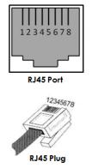

**RS232**

It can communicate with the upper computer through RS232 interface and monitor various battery information through the upper computer. The default baud rate is 9600bps.

|  |  |
| --- | --- |
| Pin definitions of the RS232 port | |
| Pin number | 1627464305(1)Function definition |
| Foot1,2,6 | NC |
| Foot 3 | TX |
| Foot 4 | RX |
| Foot 5 | GND |

|  |  |
| --- | --- |
| **BMS** **basic** **function** | |
| **Protection** **and** **alarm** | **Management** **and** **monitor** |
| Charge/Discharge End | Cells Balance |
| Charge Over Voltage | Intelligent Charge Model |
| Discharge Under Voltage | Charge/Discharge Current Limit |
| Charge/Discharge Over Current | Capacity Retention Calculate |
| High/Low Temperature(cell/BMS) | Administrator Monitor |
| Short Circuit | Operation Record |
|  | Power Cable Reverse |
|  | Soft start of inverter |

**4.** **Safe** **handling** **of** **lithium** **batteries** **guide**

**4.1** **Danger** **label**

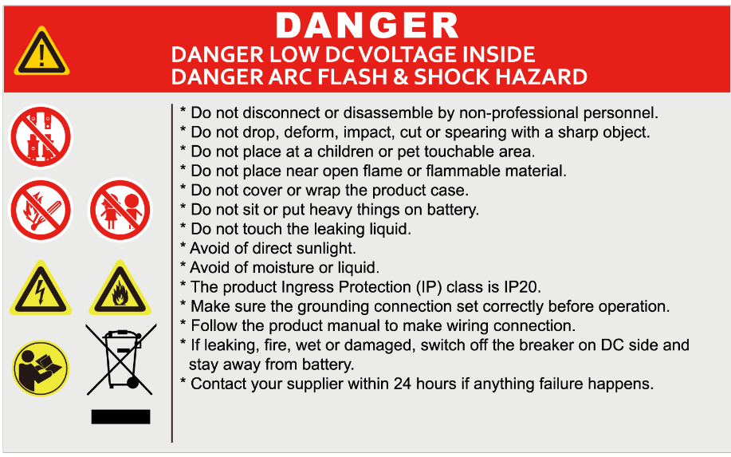

**4.2** **Tools**



Wire cutter

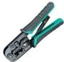

Crimping modular plier



Screwdriver

**NOTE**

Use properly insulated tools to prevent accidental electric shock or short circuits. If insulated tools are not available, cover the entire exposed metal surfaces of the available tools, except their tips, with electrical tape.

**4.2** **Safety** **gear**

It is recommended to wear the following safety gear when dealing with the

battery pack



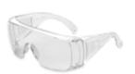

Insulated gloves



Safety shoes

Safety goggles

1. **Installation** **and** **operation**
   1. **Installation location**

Make sure that the installation location meets the following conditions:

* The area is completely waterproof
* The floor is flat and level.
* There are no flammable or explosive materials.
* The ambient temperature is within the range from 0°C to 50°C.
* The temperature and humidity are maintained at a constant level.
* There is minimal dust and dirt in the area.
* The distance from heat source is more than 2 meters.
* The distance from air outlet of inverter is more than 0.5 meters.
* The installation areas shall avoid of direct sunlight.
* There is no mandatory ventilation requirements for battery module, but please avoid of installation in confined area. The aeration shall avoid of high salinity, humidity or temperature.

 **Caution**

If the ambient temperature is out of the operating range, the battery stops operating to protect itself. The optimal temperature range for the battery pack to operate is 10°C to 40°C. Frequent exposure to harsh temperatures may deteriorate the performance and life of the battery

**5.2 For External cable kits:**

**NOTE**

Power and communication cables to connect to inverter belongs to an External Cable Kit, NOT include in battery carton box. They are in another extra small cable box. If there is anything missed please contact dealer. Two power cables and communication cable for each energy storage system.

Cable 25mm² for 100A current

Cable 50mm² for 200A current

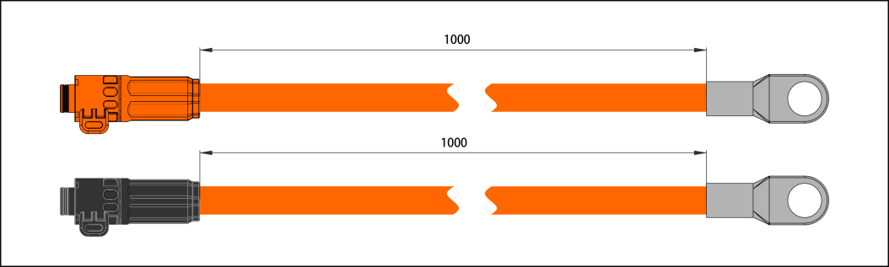

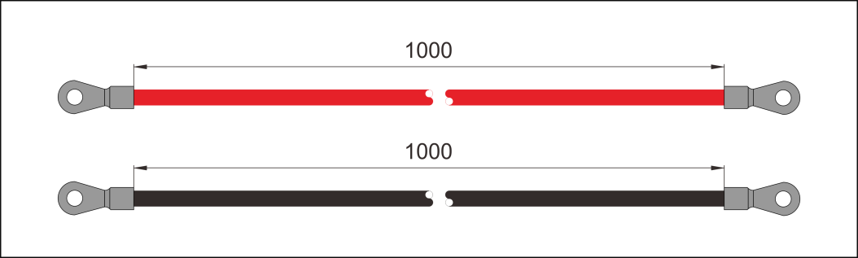

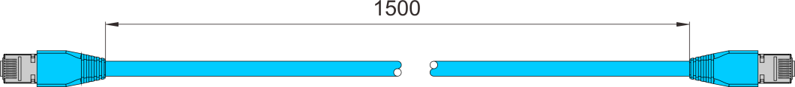

For the external cables, the length shall less than 3 meters.

**5.3** **Grounding**

Grounding cables shall be 16AWG or higher yellow-green cables. After connection, the resistance from battery grounding point to Ground connection point of room or installed place shall smaller than 0.1Ω .

based on metal directly touch between the module’s surface and rack’s surface. If using painted rack, the corresponding place shall remove the painting.

 install a grounding cable to the grounding point ofthe modules.



10AWG grounding cable

**6.** **Trouble** **shooting.**

**Communication related problem**

Unable to communicate with inverter on compatible list.

Possible conditions:

RS485: Check the baud rate. The address dial of the battery connected to the inverter is 1. Set it correctly. Check whether A and B of 485 are connected correctly

CAN: Check the baud rate. The dial address connected to the inverter is 1. Please set it correctly. Check whether the CAN-H and CAN-L connections are correct

**Functional related problem**

1) Whether the battery can be turned on or not

2) If battery is turned on, check the red light is off, flashing or lighting

3) If the red light is off, check whether the battery can be charged/discharged or not.

**Possible conditions:**

1) Battery cannot turn on, switch ON and press the red SW the lights are all no lighting or flashing.

1.1) Capacity too low, or module over discharged.

1.2) solution: use a charge or inverter to provide 56V-56.8V voltage. If battery can start, then keep charge the module and use monitor tools to check the battery log.

1.3) If battery terminal voltage is ≤46Vdc, please use ≤0.05C to slowly charge the module to avoid affect to SOH.

1.4) If battery terminal voltage is ＞46Vdc, it can use ≤0.5C to charge.

1.5) If battery cannot start, turn off battery and repair.

2)  The battery can turn on, but red light is lighting, and cannot charge or discharge. If the red light is lighting, that means system is abnormal, please check values as following

2.1) Temperature: Above 60°C or under - 10°C , the battery could not work .

Solution: to move battery to the normal operating temperature range between 0°C and 50°C

2.2) Current: If current exceeds 110% current, battery protection will turn on.

Solution: Check whether current is too large or not, if it is, change the settings on power supply side.

2.3) High Voltage: If charging voltage above 58.4V, battery protection will turn on. Solution: Check whether voltage is too high or not, if it is, to change the settings on power supply side. And discharge the module.

2.4) Low Voltage: When the battery discharges to 46.4V or less, battery protection will turn on.

Solution: Charge the battery till the red light turns off.

2.5) Cell voltage high. The module voltage is lower than 54V, SOC LED does not all on. When discharge the module protection disappear.

Solution: keep charge the module by 54-56V or keep the system cycle. The BMS can balance the cell during cycling.

3) Unable to charge and discharge with red LED on. The temperature is 0~50 degree. Use charger to charge, not possible. Use load to discharge, not possible.

3.1) Under permanent protection. The single cell voltage has been higher than

3.65V or lower than 1.5 or temperature higher than 80 degree. Solution: Switch off the module and contact your local distributor for repair.

3.2) High voltage protection.

Cell voltage higher than 3.65V or module voltage higher than 58.4V. Solution: Battery system requires properly established communication with inverter and correctly settings on inverter to run safely. Check the setting of the inverter or charger, the charge voltage shall be 56.8V~56Vdc; Check the communication between battery system and inverter whether established or not; Check the ADD switch on battery module whether is set correctly or not;

3.3)  MOSFAIL.

Solution: Battery system requires properly established communication with inverter and correctly settings on inverter to run safely. Power off all battery and inverters. Disconnect breaker. Check the cable connection and disconnect all power cables. Check the power port damaged or not. Check the setting of inverter or charger, check the communication between inverter and battery system.

Try turn on the single module, without any cable connected. If still buzzer

rings. Then switch off the module and contact your local distributor.

3.4) BMS failure.

Solution：Switch off the module and contact your local distributor.

**Excluding the points above, if the faulty still cannot be located, turn off battery and contact your local distributor.**

1. **Emergency** **Situations**

1) Leaking Batteries

If the battery pack leaks electrolyte, avoid contact with the leaking liquid or gas. If one is exposed to the leaked substance, immediately perform the actions described below.

1.1) Inhalation: Evacuate the contaminated area and seek medical attention.

1.2) Contact with eyes: Rinse eyes with flowing water for 15 minutes and seek medical attention.

1.3) Contact with skin: Wash the affected area thoroughly with soap and water and seek medical attention.

Ingestion: Induce vomiting and seek medical attention.

2) Fire

NO WATER! Only dry powder fire or carbon dioxide extinguisher can be used; if possible, move the battery pack to a safe area before it catches fire.

3) Wet Batteries

If the battery pack is wet or submerged in water, do not let people access it, and then contact Our team or an authorized dealer for technical support. Cut off all power switch on inverter side.

4) Damaged Batteries

Damaged batteries are dangerous and must be handled with the utmost care. They are not fit for use and may pose a danger to people or property. If the battery pack seems to be damaged, pack it in its original container, and then return it to Our team or an authorized dealer.

 **Caution**

Damaged batteries may leak electrolyte or produce flammable gas.

**8.** **Remarks**

**Recycle** **and** **disposal**

In case a battery (normal condition or damaged) needs disposal or needs recycling, it shall follow the local recycling regulation (i.e. Regulation (EC) Nº 1013/2006 among European Union) to process, and using the best available techniques to achieve a relevant recycling efficiency.



**Storage,** **Maintenance** **and** **Expansion**

1) It is required to charge the battery at least once every 6 months, for this charge maintenance make sure the SOC is charged to higher than 90%

2) Every year after installation. The connection of power connector, grounding point, power cable and screw are suggested to be checked. Make sure there is no loose, no broken, no corrosion at connection point. Check the installation environment such as dust, water, insect etc. make sure it is suitable for IP20 battery system .

3) If the battery is stored for long time, it is required to charge them every six months, and the SOC should be higher than 90%.

4) A new battery module can be add onto an existing system at any time. Please make sure the new battery is acting as the master. The new module, due to a higher SOH may have a difference on SOC with existing system, but it will not affect the parallel connection system performance.