**Energy storage all-in-one**

User Manual

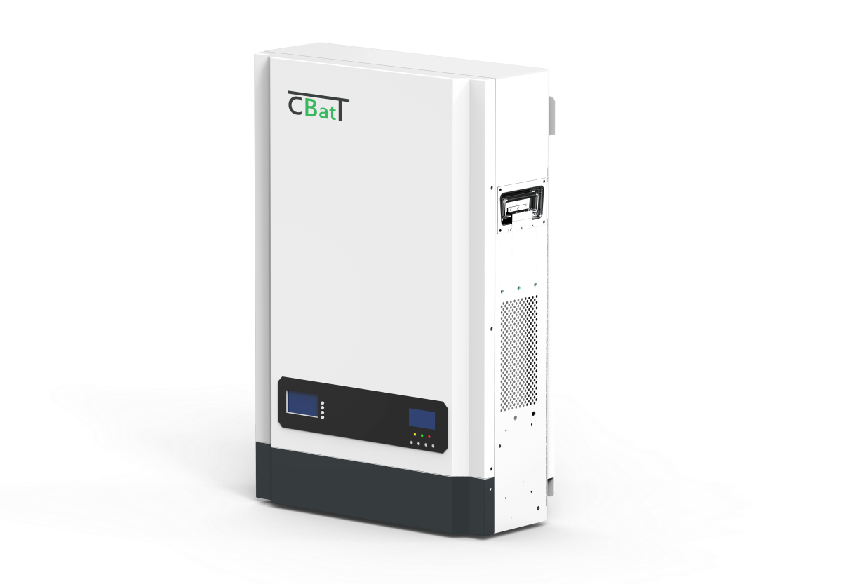

#### Important safety instructions

**Please keep this manual for future use.**

This manual provides users with product information, detailed installation and use, fault diagnosis and troubleshooting, and daily maintenance related precautions of the energy storage integrated machine, and does not contain all the information of the energy storage system. In order to ensure the correct installation and use of the energy storage integrated machine and give full play to its superior performance, before handling, installing, running and maintaining this product, please read the instruction manual in detail and follow all the safety precautions in the manual.

Please read all instructions and precautions in the manual carefully before installation and use.

* The use of this energy storage all-in-one product must comply with local laws and regulations related to grid-connected power generation.
* Do not install the all-in-one solar charge inverter in harsh environments such as moist, oily, flammable or explosive, or heavily dusty areas.
* The company reserves the right to continuously improve the product and update the contents of this manual without prior notice.
* Due to the deviation between the actual product and the data caused by the continuous update of the product, please refer to the actual product.

CONTENTS

1. General information 4

1.2 Basic system introduction 5

1.3 Appearance 6

1.4 Installation and wiring 7

2. Operating modes 10

2.1 Charging mode 10

2.2 Output mode 11

3. LCD screen operating instructions 12

3.1 Operation and display panel 12

3.2 Setup parameters description 16

4. Other functions 22

4.1 Dry node 22

4.2 RS485 communication port 22

4.3 USB communication port 22

5. Protection 23

5.1 Protections provided 23

5.2 Fault code meaning 25

5.3 Handling measures for part of faults 26

6.System maintenance 27

# General information

#### Product overview and features

The product is an energy storage inverter integrated machine, featuring high integration, high reliability, convenient installation, ETC; The inverter module is designed with a mature scheme, and the lithium battery is lithium iron phosphate battery (LiFePO4), which is characterized by high reliability, high safety and long cycle life. The battery is equipped with an intelligent BMS lithium battery management system, which has the functions of overcharge protection, over discharge protection, temperature protection, over-current protection, etc., and comprehensively monitors the key parameters of the battery.

###### Features:

1. Full digital voltage and current double closed loop control, advanced SPWM technology, output of pure sine wave.
2. Two output modes: mains bypass and inverter output; uninterrupted power supply.
3. Available in 4 charging modes: Only Solar, Mains Priority, Solar Priority and Mains & Solar hybrid charging.
4. Advanced MPPT technology with an efficiency of 99.9%.
5. ON/OFF rocker switch for AC output control.
6. Power saving mode available to reduce no-load loss.
7. Intelligent variable speed fan to efficiently dissipate heat and extend system life.
8. 360 ° all-round protection with a number of protection functions.
9. Complete protections, including short circuit protection, over voltage and under voltage protection, overload protection, reverse protection, etc.
10. This device can be used to monitor the status of the system anytime, anywhere through mobile phones or web pages.

### Basic system introduction

The figure below shows the system application scenario of this product. A complete system consists of the following parts:

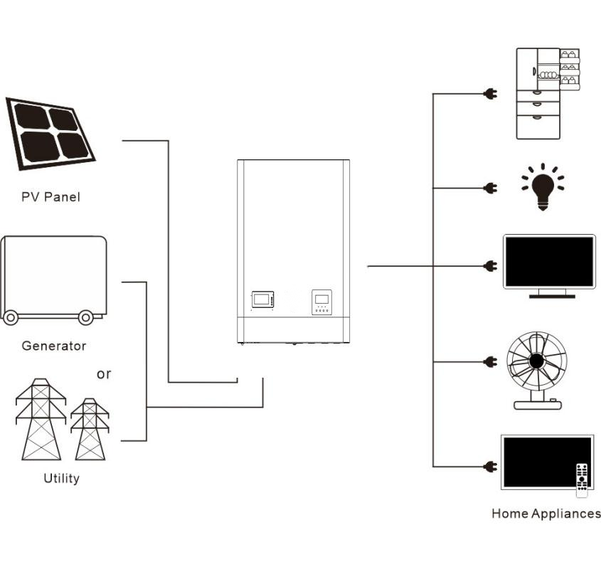

Energy storage all-in-one

### **5kw斜角cp3**Appearance

### 

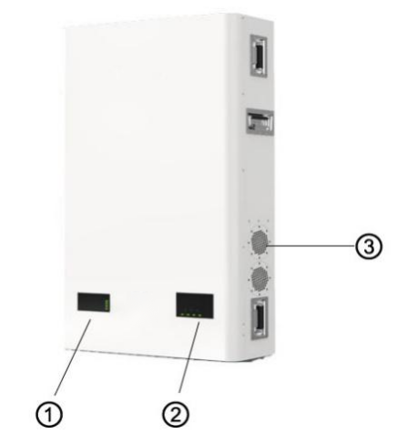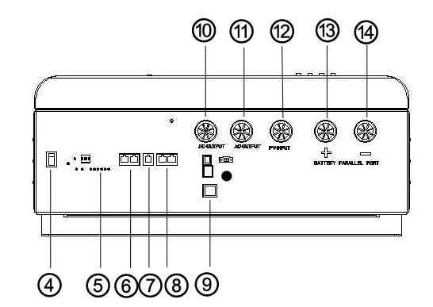

|  |  |  |  |
| --- | --- | --- | --- |
| ① | Battery pack LCD screen | ⑧ | Battery pack RS485 communication port |
| ② | Inverter LCD screen | ⑨ | USB communication port |
| ③ | Cooling fan | ⑩ | AC input |
| ④ | Inverter switch | ⑪ | AC output |
| ⑤ | Battery pack indicator light | ⑫ | PV input |
| ⑥ | Battery and inverter communication port | ⑬ | Battery pack output + |
| ⑦ | Battery pack RS232 | ⑭ | Battery pack output - |

### Installation and wiring

###### Installation steps:

**Step 1:** In order to ensure good ventilation of the energy storage integrated cabinet, please reserve sufficient installation spacing around the energy storage integrated cabinet during installation.



**Note:** The narrowest maintenance channel, escape line, etc., the specific requirements also need to refer to the / the country where the project is located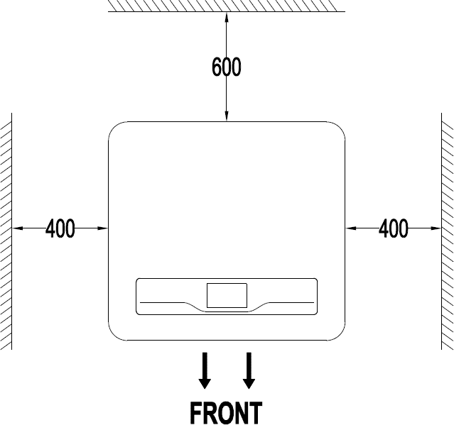

|  |  |
| --- | --- |
| Plane | Minimum spacing |
| Side distance | 400mm |
| Back distance | 600mm |

|  |
| --- |
| ***DANGER***  • Do not install the inverter where highly flammable materials are near by.  • Do not install the inverter in potential explosive areas.  • Do not install the inverter with lead-acid batteries in a confined space.  ***CAUTION***  • Do not install the inverter in direct sunlight.  • Do not install or use the inverter in a humid environment. |

### System installation drawing

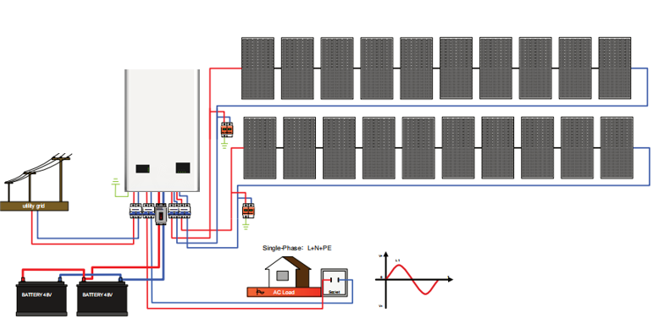

**Precautions for use:** 3kw model P4L-OMVG2-03KW can only be used on a single machine, and cannot be used with multiple machines in parallel. If greater power is required, other models that meet the power requirements can be selected for installation

**Step1:** Wiring

**AC** load and **PV** photovoltaic:

① Only AC transmission cables that are protected in accordance with local electrical safety regulations and comply with the technical parameters of this manual are allowed to be connected to the energy storage integrated machine.

② Foer safe operation of the system, it is recommended to use the cable specifications as shown in the following table:

|  |  |  |
| --- | --- | --- |
| Energy storage all-in-one model | Mains access | Load access |
| Recommended minimum cross-sectional area mm² (length≤ 50m) | The minimum cross-sectional area is recommended  mm² (length≤ 50m) |
| 3kW / 5kW  8KW/10kW | 6 | 4 |

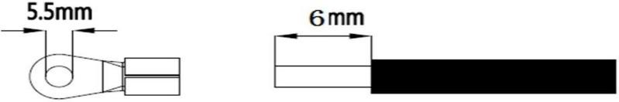③Mains, load L, N, PE stripping length, crimping terminal crimping torque is 3.6~4.6N·m

##### ：Ground L： Live N： Neutral

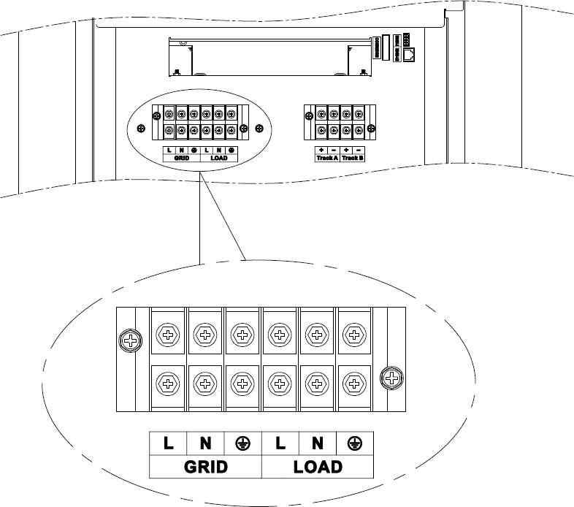

**Step 4:** Check if the wiring is correct and firm. In particular, check if the battery polarity is reversed, if the PV input polarity is reversed and if the AC input is properly connected.

**Note:** The grounding wire should be as thick as possible (cross-sectional area not less than 4mm2). The grounding point should be as close as possible to the energy storage integrated machine. The shorter the ground wire, the better.

###### Warnings:

① Mains input, AC output and PV array will generate high voltage. So, before wiring, be sure to disconnect the circuit breaker or fuse;

②Before wiring, be sure to disconnect the circuit breaker to prevent strong electric sparks and avoid battery short circuit; if the all-in-one solar charge inverter is used in an area with frequent lightning, it is recommended to install an external lightening arrester at the PV input terminal.

# Operating modes

### Charging mode

1. PV priority: PV module will charge the battery preferentially, and the battery is charged by the Mains only when the PV system fails. During the day, solar energy is fully used to charge, while at night, it converts to the Mains. This can maintain battery level, and is ideal for areas where the grid is relatively stable and electricity price is relatively high.

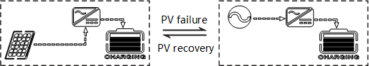

1. Mains priority: The Mains supply is preferentially used to charge the battery. Only when the Mains fails, the PV charging can be activated.

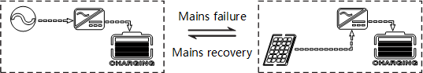

1. Hybrid charging: PV and mains hybrid charging. PV MPPT charging is a priority, and when PV energy is insufficient, the mains supply supplements. When the PV energy is sufficient again, the mains stops charging. This is the fastest charging mode, suitable for the areas where power grid is unstable, providing sufficient backup power supply at any time.

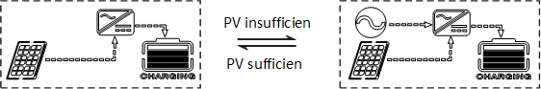

1. Only Solar (Only Solar): Only PV charging, without Mains charging. This is the most energy-efficient way in which battery is charged only by solar panels, and is usually used in areas with good lighting conditions.

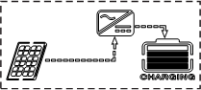

### Output mode

###### PV priority mode:

Switch to mains supply when the PV charging fails. This mode maximizes the use of solar energy while maintaining battery power, suitable for use in the areas with relatively stable grid.

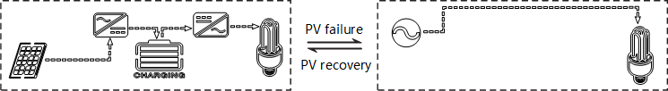

###### Mains priority mode:

Switch to inverter only when the mains fails (when there was mains power, switch to mains power for charging and power supply).Then, the unit is equivalent to a backup UPS, suitable for areas with unstable grid. Switching does not affect PV charging.

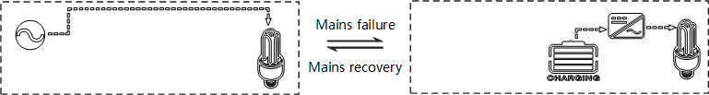

###### Inverter priority mode:

Switch to mains supply only when the battery discharge undervoltage is lower than the set point (item 04). When the charging battery is higher than the set point of (05 setting item), switch to the battery discharge mode. This can cycle the battery charge and discharge. This mode maximizes the use of DC power and is used in the area with stable grid. Switching does not affect PV charging.

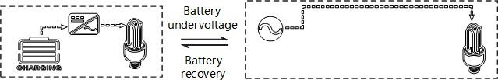

# LCD screen operating instructions

### Operation and display panel

The operation and display panel is as shown below, including 1 LCD screen, 3 indicators and 4 operation buttons.

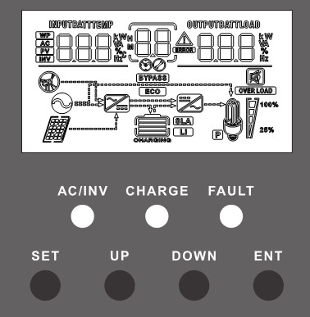

**Operation buttons introduction**

|  |  |
| --- | --- |
| **Function**  **buttons** | **Description** |
| SET | Enter/Exit Settings menu |
| UP | Previous choice |
| DOWN | Next choice |
| ENT | Confirm/Enter Options under the settings menu, |

**Indicators introduction**

|  |  |  |
| --- | --- | --- |
| **Indicators** | **Colors** | **Description** |
| AC/INV | Yellow | Steady on: Mains output |
| Flash: Inverter output |
| CHARGE | Green | Flash: Battery charging |
| Steady on: Charging completed |
| FAULT | Red | Steady on: Fault state |

**LCD screen introduction**

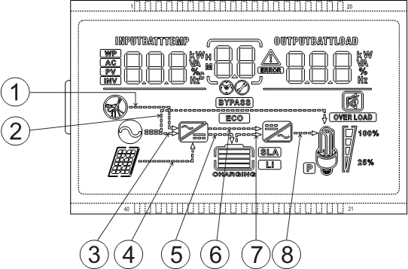

|  |  |  |  |
| --- | --- | --- | --- |
| **Icons** | **Functions** | **Icons** | **Functions** |
|  | Indicates that the AC input terminal has been connected to  the grid |  | Indicates that the inverter circuit is working |
|  | Indicates that the AC input mode  in APL mode (wide voltage range) |  | Indicates that the machine is in  the Mains Bypass mode |
|  | Indicates that the PV input terminal has been connected to the solar  panel |  | Indicates that the AC output is in an overload state |
|  | Indicates that the machine has been connected to the battery:  indicates that the remaining battery is 0%~24%;  indicates that the remaining battery is 25%~49%;  indicates that the remaining battery is 50%~74%;  indicates that the remaining battery is 75%~100%. |  | Indicates the percentage of AC output loads:  indicates that the load percentage is 0%~24%;  indicates that the load percentage is 25%~49%,  indicates that the load percentage is 50%~74%,  indicates that the load percentage is ≥75%. |
|  | Indicates that the battery type of  the machine is a lithium battery |  | Indicates that the buzzer is not  enabled |

|  |  |  |  |
| --- | --- | --- | --- |
|  | Indicates that the current battery type of the machine is a lead-acid  battery |  | Indicates that the machine has an alarm |
|  | Indicates that the battery is in  charging state |  | Indicates that the machine is in a  fault condition |
|  | Indicates that the AC/PV charging  circuit is working |  | Indicates that the machine is in  setup mode |
|  | Indicates that the AC output terminal has an AC voltage output |  | The parameters displayed in the middle of the screen:   1. In the non-setup mode, the alarm or fault code is displayed. 2. In the setup mode, the currently set parameter item code is displayed. |
| Parameters display on the left side of the screen: input parameters | | | |
|  | Indicates AC input | | |
|  | Indicates PV input | | |
|  | Indicates inverter circuit | | |
|  | This icon is not displayed | | |
|  | Display battery voltage, battery charge total current, mains charge power, AC input voltage, AC input frequency, PV input voltage, internal heat sink temperature,  software version | | |
| Parameters display on the right side of the screen: Output parameters | | | |
|  | Indicates output voltage, output current, output active power, output apparent power, battery discharge current, software version; in setup mode, displays the set  parameters under the currently set parameter item code | | |
| **Arrow display** | | | |
| ① | The arrow is not displayed | ⑤ | Indicates the charging circuit  charging the battery terminal |
| ② | Indicates the grid supplying power  to the load | ⑥ | The arrow is not displayed |
| ③ | Indicates grid supplying power to the charging circuit | ⑦ | Indicates the battery terminal supplying power to the inverter  circuit |
| ④ | Indicates PV module supplying  power to the charging circuit | ⑧ | Indicates the inverter circuit  supplying power to the load |

**Real-time data viewing method**

On the LCD main screen, press the “UP” and “DOWN” buttons to scroll through the real-time data of the machine.

|  |  |  |  |
| --- | --- | --- | --- |
| **Page** | **Parameters on the left side of the screen** | **Parameters in the middle of**  **the screen** | **Parameters on the right side of the screen** |
| 1 | INPUT BATT V  (Battery input voltage) | Fault code | OUTPUT LOAD V (Output  load voltage) |
| 2 | PV TEMP ℃  (PV charger heatsink temperature) | PV OUTPUT KW  (PV output power) |
| 3 | PV INPUT V  (PV input voltage) | PV OUTPUT A  (PV output current) |
| 4 | INPUT BATT A  (Input battery current) | OUTPUT BATT A  (Battery output current) |
| 5 | INPUT BATT KW  (Battery input power) | OUTPUT BATT KW  (Battery output power) |
| 6 | AC INPUT Hz  (AC input frequency) | AC OUTPUT LOAD Hz  (AC output frequency) |
| 7 | AC INPUT V  (AC input voltage) | AC OUTPUT LOAD A  (AC output load current) |
| 8 | INPUT V  (For maintain) | OUTPUT LOAD KVA  (Load apparent power) |
| 9 | INV TEMP ℃  (AC charge or battery discharge  heatsink temperature) | INV OUTPUT LOAD KW  (Load active power) |
| 10 | APP software version | Bootloader software version |
| 11 | Model Battery Voltage Rating | Model Output Power Rating |
| 12 | Model PV Voltage Rating | Model PV Current Rating |

### Setup parameters description

Buttons operation instructions: Press the “SET” button to enter the setup menu and exit the setup menu. After entering the setup menu, the parameter number [00] will flash. At this point, press the “UP” and “DOWN” buttons to select the code of parameter item to be set. Then, press the “ENT” button to enter the parameter editing mode, and the value of the parameter is flashing. Adjust the value of the parameter with the “UP” and “DOWN” buttons. Finally, press the “ENT” button to complete the parameter editing and return to the parameter selection state.

|  |  |  |  |
| --- | --- | --- | --- |
| **Parameter no.** | **Parameter name** | **Settings** | **Description** |
| **00** | Exit setting menu | [00] ESC | Exit the setup menu |
| **01** | Output source priority | [01] SOL | PV priority mode, switching to the Mains when the PV fails or the battery is lower than the set  value of parameter [04]. |
| [01] UTI **default** | Mains priority mode, switching to inverter only when the mains fails. |
| [01] SBU | Inverter priority mode, switching to the mains only when the battery is under voltage or lower  than the set value of parameter [04]. |
| **02** | Output Frequency | [02] 50.0 | Bypass self-adaptation; when the mains is connected, it automatically adapts to the mains frequency; when the mains is disconnected, the output frequency can be set through this menu. The default output frequency of the 230V  machine is 50HZ; |
| [02] 60.0 |
| **03** | AC Input Voltage Range | [03] APL | Wide mains input voltage range of 230V machine: 90~280V |
| [03] UPS **default** | Narrow mains input voltage range of 230V machine: 170~280V |
| **04** | Battery Power to Utility Setpoint | [04] 21.8 **default** | When the parameter [01] =SOL/SBU, the battery voltage is lower than the set value, and the output is switched from the inverter to the mains. Setting range: 22V~26V. Cannot exceed  the value of [14] settings. |

|  |  |  |  |
| --- | --- | --- | --- |
| **Parameter no.** | **Parameter name** | **Settings** | **Description** |
| **05** | Utility to Battery Power Setpoint | [05]28.8V  **default** | When the parameter [01] =SOL/SBU, the battery voltage is higher than the set value, and the output is switched from the mains to the inverter. Setting range: 24V~30V. Cannot be  lower than the value of [04] / [35] settings. |
| **06** | Charger source priority | [06] CSO | PV priority charging; only when the PV charging fails, the mains charging is started. |
| [06] CUB | Mains priority charging; only when the mains charging fails, the PV charging is started. |
| [06] SNU **default** | PV and Mains hybrid charging; PV charging is a priority, and when the PV energy is insufficient, the Mains charging supplements. When the PV energy is sufficient, the Mains charging stops. Note: Only when the Mains bypass output is loaded, the PV charging and the mains charging can work at the same time. When the inverter works, only the PV charging can be  started. |
| [06] OSO | Only PV charging, with the Mains charging not activated. |
| **07** | Max charger current | [07] 60A **default** | 230V Max charger current (AC charger+PV charger). Setting range: 0~140A； |
| **08** | Battery Type | [08] USE | User-defined; all battery parameters can be set. |
| [08] SLd | Sealed lead-acid battery; constant-voltage charge voltage: 28.8V, floating charge voltage:  27.6V. |
| [08] FLd | Vented lead-acid battery; constant-voltage charge voltage: 29.2V, floating charge voltage:  27.6V. |
| [08] GEL **default** | Colloidal lead-acid battery; constant-voltage charge voltage: 28.4V, floating charge voltage:  27.6V. |

|  |  |  |  |
| --- | --- | --- | --- |
| **Parameter no.** | **Parameter name** | **Settings** | **Description** |
|  |  | [08] LF07/LF08/LF09 | Lithium iron phosphate battery LF07/LF08/LF09, corresponding to 7 strings ,8 strings and 9 strings of lithium iron phosphate battery; for 7 strings, default constant-voltage charge voltage is 24.8V; for 8 strings, default constant-voltage charge voltage is 28.4V; for 9 strings, default constant-voltage charge voltage is 31.8V; allow  adjustable. |
| [08] NCA | Ternary lithium battery; the default constant- voltage charge voltage is 28.4V, which is  adjustable. |
| **09** | Battery boost charge voltage | [09] 28.8V  **default** | Boost charge voltage setting; the setting range is 24V~29.2V, with step of 0.2V; it is valid for  user-defined battery and lithium battery. |
| **10** | Battery boost charge time | [10] 120 **default** | Boost charge maximum time setting, which means the maximum charging time to reach the set voltage of parameter [09] during constant-voltage charging. The setting range is 5min~900min, with a step of 5 minutes. It is valid for user-defined battery and lithium  battery. |
| **11** | Battery floating charge voltage | [11] 27.6V  **default** | Floating charge voltage, setting range: 24V~229.V, step: 0.2V, valid when battery type  is user-defined. |
| **12** | Battery over discharge voltage (delay off) | [12] 21V **default** | Over-discharge voltage; when the battery voltage is lower than this judgment point, delay the time set by parameter [13] and turn off inverter output. Setting range is 20V~24V, with a step of 0.2V. It is valid for user-defined  battery and lithium battery. |
| **13** | Battery over discharge delay time | [13] 5S **default** | Over-discharge delay time; when the battery voltage is lower than the parameter [12], the inverter output will be turned off after the time set by this parameter is delayed. The setting range is 5S~55S, with a step of 5S. It is valid for  user-defined battery and lithium battery. |

|  |  |  |  |
| --- | --- | --- | --- |
| **Parameter no.** | **Parameter name** | **Settings** | **Description** |
| **14** | Battery under voltage alarm | [14] 22V **default** | Battery undervoltage alarm point; when the battery voltage is lower than the point, an undervoltage alarm is given, and the output is not turned off; the setting range is 20V~26V, with a step of 0.2V. It is valid for user-defined  battery and lithium battery. |
| **15** | Battery discharge limit voltage | [15] 20V **default** | Battery discharge limit voltage; when the battery voltage is lower than the point, the output is turned off immediately; the setting range is 20V~26V, with a step of 0.2V. It is valid  for user-defined battery and lithium battery. |
| **16** | Battery equalization enable | [16] DIS | Equalizing charge is disabled |
| [16] ENA **default** | Equalizing charge is enabled, only valid for vented lead-acid battery and sealed lead-acid  battery |
| **17** | Battery equalization  voltage | [17] 29.2V  **default** | Equalizing charge voltage; setting range: 24V~29.2V, with a step of 0.2V; valid for vented  lead-acid battery and sealed lead-acid battery |
| **18** | Battery equalized time | [18] 120 **default** | Equalizing charge time; setting range: 5min~900min, with a step of 5 minutes; valid for vented lead-acid battery and sealed lead-  acid battery |
| **19** | Battery equalized time out | [19] 120 **default** | Equalizing charge delay; setting range: 5min~900min, with a step of 5 minutes; valid for vented lead-acid battery and sealed lead-  acid battery |
| **20** | Battery equalization  interval | [20] 30 **default** | Equalizing charge derating time, 0~30days, with a step of 1 day; valid for vented lead-acid  battery and sealed lead-acid battery |
| **21** | Battery equalization immediately | [21] DIS | Stop equalizing charge immediately. |
| [21] ENA **default** | Start equalizing charge immediately. |
| **22** |  | [22] DIS **default** | Power saving mode disabled. |

|  |  |  |  |
| --- | --- | --- | --- |
| **Parameter no.** | **Parameter name** | **Settings** | **Description** |
|  | Power saving mode | [22] ENA | After the power saving mode is enabled, if the load is null or less than 50W, the inverter output is turned off after a delay for a certain period of time. When the load is more than  50W, the inverter automatic restart. |
| **23** | Restart when over load | [23] DIS | Automatic restart when overload is disabled. If an overload occurs and the output is turned off,  the machine will not restart. |
| [23] ENA **default** | Automatic restart when overload is enabled. If an overload occurs and the output is turned off, the machine will restart after a delay of 3 minutes. After it reaches 5 cumulative times,  the machine will not restart. |
| **24** | Restart when over temperature | [24] DIS | Automatic restart when over temperature is disabled. If an over-temperature shutdown occurs, machine will not restart to turn the  output on. |
| [24] ENA **default** | Automatic restart when over temperature is enabled. If an over-temperature shutdown occurs, the machine will restart when the  temperature drops. |
| **25** | Alarm enable | [25] DIS | Alarm is disabled |
| [25] ENA **default** | Alarm is enabled |
| **26** | Beeps while primary source is interrupted | [26] DIS | Alarm beep is disabled when the status of the main input source changes |
| [26] ENA **default** | Alarm beep is enabled when the status of the main input source changes |
| **27** | Bypass output when over load | [27] DIS | It is disabled to automatically switch to the Mains when the inverter is overloaded. |
| [27] ENA **default** | It is enabled to automatically switch to the Mains when the inverter is overloaded. |

|  |  |  |  |
| --- | --- | --- | --- |
| **Parameter no.** | **Parameter name** | **Settings** | **Description** |
| **28** | Max AC charger current | [28] 80A **default** | **S series model**：Max AC charger current. Setting range: 0~80A； |
| **29** | Split Phase | [29] DIS **default** | Supply for industrial frequency transformer (disabled) |
| [29] ENA | Supply for industrial frequency transformer (enabled) |
| **35** | Battery undervoltage  recovery point | [35] 26V **default** | When the battery voltage is under voltage, the battery voltage needs to recover more than this  set value before the inverter starts the output |
| **36** | Max PV charger current | [36] 60A **default** | Max PV charger current. Setting range: 0~60A |
| **37** | Battery fully charged  recovery point | [37] 26V **default** | After the battery is fully charged, it needs to be lower than this set voltage before it can be  recharged |
| **38** | AC output voltage setting (only can be set in the standby  mode ) | [38]230Vac  **default** | **S series model**：230Vac **default**.  Allow to set to 200/208/220/230/240Vac. The rated output power will be reduced= (Power Rate)*(Vset/230) |

# Other functions

### Dry node

Working principle: This dry node can control the ON/OFF of the diesel generator to charge the battery. ① Normally, the terminals are that the NC-N point is closed and the NO-N point is open; ② When the battery voltage reaches the low voltage disconnection point, the relay coil is energized, and the terminals turn to that the NO-N point is closed while NC-N point is open. At this point, NO-N point can drive resistive loads: 125VAC/1A, 230VAC/1A, 30VDC/1A.

### RS485 communication port

This port is an RS485 communication port;

###### This port is an RS485 communication port which comes with two functions:

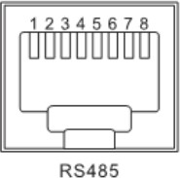① It allows direct communication with the optional host computer developed by our company through this port, and enables monitoring of the equipment running status and setting of some parameters on the computer;

② It also allows direct connection with the optional RS485 to WiFi/GPRS communication module developed by our company through this port. After the module is selected, you can connect the all-in-one solar charge inverter through the mobile phone WiFi/GPRS APP, on which you can view the operating parameters and status of the device.

###### As shown in the figure:

Pin 1 is 5V power supply, Pin2 is GND, Pin is RS485-A, and Pin 8 is RS485-B; Pin 5 is CAN-H, and Pin 6 is CAN-L;

### USB communication port

This is a USB communication port, which can be used for USB communication with the optional PC host software. To use this port, you should install the corresponding "USB to serial chip CH340T driver" and APP in the computer.

# Protection

### Protections provided

|  |  |  |
| --- | --- | --- |
| **No.** | **Protections** | **Description** |
| **1** | PV current/power limiting protection | When charging current or power of the PV array configured exceeds the PV rated, it will charge at the rated. |
| **2** | PV night reverse- current protection | At night, the battery is prevented from discharging through the PV module because the battery voltage is greater than the voltage of PV module. |
| **3** | Mains input over voltage protection | When the mains voltage exceeds 280V (230V model) or 140V (120V model), the mains charging will be stopped and switched to the inverter mode. |
| **4** | Mains input under voltage protection | When the mains voltage is lower than 170V (230V model /UPS mode) or 90V (120V model or APL mode), the mains charging will be stopped and switched to the inverter mode. |
| **5** | Battery over voltage protection | When the battery voltage reaches the overvoltage disconnection point, the PV and the mains will be automatically stopped to charge the battery to prevent the battery from being overcharged and  damaged. |
| **6** | Battery low voltage protection | When the battery voltage reaches the low voltage disconnection point, the battery discharging will be automatically stopped to prevent the battery from being over-discharged and damaged. |
| **7** | Load output short circuit protection | When a short-circuit fault occurs at the load output terminal, the AC output is immediately turned off and turned on again after 1 second. |
| **8** | Heat sink over temperature protection | When the internal temperature is too high, the all-in-one machine will stop charging and discharging; when the temperature returns to normal, charging and discharging will resume. |
| **9** | Overload protection | Output again 3 minutes after an overload protection, and turn the output off after 5 consecutive times of overload protection until the machine is re-powered. For the specific overload level and duration,  refer to the technical parameters table in the manual. |

|  |  |  |
| --- | --- | --- |
| **10** | PV reverse polarity protection | When the PV polarity is reversed, the machine will not be damaged. |
| **11** | AC reverse protection | Prevent battery inverter AC current from being reversely input to Bypass. |
| **12** | Bypass over current protection | Built-in AC input overcurrent protection circuit breaker. |
| **13** | Battery input over current protection | When the discharge output current of the battery is greater than the maximum value and lasts for 1 minute, the AC input would switched to load. |
| **14** | Battery input protection | When the battery is reversely connected or the inverter is short- circuited, the battery input fuse in the inverter will blow out to prevent the battery from being damaged or causing a fire. |
| **15** | Charge short protection | When the external battery port is short-circuited in the PV or AC charging state, the inverter will protect and stop the output current. |

### Fault code meaning

|  |  |  |  |
| --- | --- | --- | --- |
| **Fault code** | **Fault name** | **Whether it affects the**  **output or not** | **Description** |
| **【01】** | BatVoltLow | Yes | Battery undervoltage alarm |
| **【02】** | BatOverCurrSw | Yes | Battery discharge average current  overcurrent software protection |
| **【03】** | BatOpen | Yes | Battery not-connected alarm |
| **【04】** | BatLowEod | Yes | Battery undervoltage stop discharge alarm |
| **【05】** | BatOverCurrHw | Yes | Battery overcurrent hardware protection |
| **【06】** | BatOverVolt | Yes | Charging overvoltage protection |
| **【07】** | BusOverVoltHw | Yes | Bus overvoltage hardware protection |
| **【08】** | BusOverVoltSw | Yes | Bus overvoltage software protection |
| **【09】** | PvVoltHigh | No | PV overvoltage protection |
| **【10】** | PvBuckOCSw | No | Buck overcurrent software protection |
| **【11】** | PvBuckOCHw | No | Buck overcurrent hardware protection |
| **【12】** | bLineLoss | No | Mains power down |
| **【13】** | OverloadBypass | Yes | Bypass overload protection |
| **【14】** | OverloadInverter | Yes | Inverter overload protection |
| **【15】** | AcOverCurrHw | Yes | Inverter overcurrent hardware protection |
| **【17】** | InvShort | Yes | Inverter short circuit protection |
| **【19】** | OverTemperMppt | No | Buck heat sink over temperature protection |
| **【20】** | OverTemperInv | Yes | Inverter heat sink over temperature  protection |
| **【21】** | FanFail | Yes | Fan failure |
| **【22】** | EEPROM | Yes | Memory failure |
| **【23】** | ModelNumErr | Yes | Model setting error |
| **【26】** | RlyShort | Yes | Inverted AC Output Backfills to Bypass AC  Input |
| **【29】** | BusLow | Yes | Internal battery boost circuit failure |

### Handling measures for part of faults

|  |  |  |
| --- | --- | --- |
| **Fault**  **code** | **Faults** | **Handling measures** |
| **Display** | No display on the screen | Check if the battery air switch or the PV air switch has been closed; if the switch is in the "ON" state; press any  button on the screen to exit the screen sleep mode. |
| **【06】** | Battery overvoltage protection | Measure if the battery voltage exceeds rated, and turn off the PV array air switch and Mains air switch. |
| **【01】【04】** | Battery undervoltage protection | Charge the battery until it returns to the low voltage disconnection recovery voltage. |
| **【21】** | Fan failure | Check if the fan is not turning or blocked by foreign object. |
| **【19】【20】** | Heat sink over temperature protection | When the temperature of the device is cooled below the recovery temperature, normal charge and discharge  control is resumed. |
| **【13】【14】** | Bypass overload protection, inverter overload protection | ① Reduce the use of power equipment;  ② Restart the unit to resume load output. |
| **【17】** | Inverter short circuit protection | ① Check the load connection carefully and clear the short- circuit fault points;  ② Re-power up to resume load output. |
| **【09】** | PV overvoltage | Use a multimeter to check if the PV input voltage exceeds the maximum allowable input voltage rated. |
| **【03】** | Battery missed alarm | Check if the battery is not connected or if the battery circuit breaker is not closed. |
| **【26】** | Inverted AC Output Backfills to Bypass AC Input | Disconnect the AC input,PV input and battery input. After the screen is off, only connect the battery and start up. If fault 26 is reported, it indicates that the AC input relay switch is short-circuited, and you need to contact the  manufacturer to replace it. |

# System maintenance

###### In order to maintain the best long-term performance, it is recommended to conduct following checks twice a year.

* 1. Make sure that the airflow around the unit is not blocked and remove any dirt or debris from the heat sink.
  2. Check that all exposed wires are damaged by exposure to sunlight, friction with other objects around them, dryness, bite by insects or rodents, etc., and the wires shall be repaired or replaced if necessary.
  3. Verify for the consistency of indication and display with the operation of the device. Please pay attention to the display of any faults or errors, and take corrective actions if necessary.
  4. Check all wiring terminals for corrosion, insulation damage, signs of high temperature or burning/discoloration, and tighten the screws.
  5. Check for dirt, nesting insects and corrosion, and clean up as required.
  6. If the arrester has failed, replace in time to prevent lightning damage to the unit or even other equipment of the user.

###### Warning: Danger of electric shock! When doing the above operations, make sure that all power supplies of the all-in-one machine have been disconnected, and all capacitors have been discharged, and then check or operate accordingly!

* **The company does not assume any liability for damage caused by:**

① Improper use or use in improper site.

② Open circuit voltage of the PV module exceeds the maximum allowable voltage rated.

③ Temperature in the operating environment exceeds the limited operating temperature range.

④ Disassemble and repair the all-in-one solar charge inverter without permission.

⑤ Force majeure: Damage that occurs in transportation or handling of the all-in-one solar charge inverter.